

***Introducing OF HDFC UPI NEW LAUNCH FOR SPECIFIC HDFC USERS***

**FUNCTIONAL REQUIREMENTS DOCUMENT**

**(FRD)**

|  |  |  |  |
| --- | --- | --- | --- |
| **Version** | **Description of Change** | **Author** | **Date** |
| 0.1 | Initial version of the FRD. | Noorjahan | 15/2/2025 |
| 0.2 | Introduced of HDFC New UPI launch Mobile Application | Noorjahan | 15/2/2025 |

**CONTENTS**

INTRODUCTION 5

1.1 Purpose 5

1.2 Scope 5

1.3 Project Background 6

1.4 Reference 6

Assumptions and Constraints 6

1.5.1 Assumptions 6

Constraints 6

1.5Document Overview 6

2 METHODOLOGIES 7

3 Functional Requirements 7

4 Generic Context Diagram 7

4.1 User Registration and Authentication 8

4.2 Payment Processing 9

4.3 Security Features 9

4.4 User Interface (UI) Design 9

Wireframe Design 9

4.5 Transaction History 10

4.6 Notifications 10

4.7 Account Management 10

5 Functional Requirements Group 2 – Requirements 10

5.2 Bill Payments 10

5.3 Transaction History and Management 10

5.4 Security and Authentication 11

5.5 Secure Data Encryption 11

5.6 User Interface (UI) and User Experience (UX) 11

5.7 Multi-Language Support 11

5.8 Third-Party Payment Gateway Integration 12

Requirement Gathering 12

6 Important Equipment Gathering 13

6.1 Hardware Equipment 13

6.2 POS Terminals and QR Code Generators 13

6.3 Mobile Devices (for Testing) 13

6.4 Network Infrastructure 14

7 Software and Tools 14

7.1 UPI Integration Software 14

7.2 Banking and Transaction Software 14

Software for managing banking transactions, balance management, user data security, and real-time transaction processing. 14

7.3App Development Tools 14

8 Testing Equipment and Tools 14

8.1 Device Testing Lab 14

9 Communication and Collaboration Tools 15

9.1Project Management Tools 15

9.2Collaboration Platforms 15

10 Backup and Disaster Recovery Equipment 15

10.1 Data Backup Solutions 15

Future Features for HDFC UPI Launch 16

(Requirement Gathering) 16

11.1 Cross-Border UPI Payments 16

11.2 QR Code Dynamic Payment System 17

11.3 Contactless UPI Payments 17

11.4 UPI for Bill Payments and Subscriptions 17

11.5 Enhanced Security Features 17

11.6 UPI in Offline Mode 17

11.7 Gamification and Rewards 18

12 APPENDIX A – GLOSSARY 19

# **INTRODUCTION**

# **1.1 Purpose**

"This document defines the functional and non-functional requirements for the **[INTRODUCED OF HDFC UPI NEW LAUNCH].** It serves as a detailed reference for developers, testers, and stakeholders to ensure alignment on project objectives."

# **1.2 Scope**

This FRD cover the functionality of the UPI New Launch mobile Application Process:

* **Account Linking**

(Ability for users to link their HDFC Bank accounts to the UPI system for transaction processing.)

* **UPI Payments**
* **Payment Requests**

(Users can send and receive payment requests, including bill payments, merchant payments, and invoice settlements.)

* **Transaction Limits**

**(**Define and implement transaction limits, such as maximum per-day transactions or limits per transaction for security and regulatory compliance.)

* **Security Features**
* **Balance Check and Mini Statements**
* **ATM and Branch Integration**
* **International Payments**

(The UPI system will initially support domestic payments only, with international transaction capabilities not included in this version.)

The **scope** based on the specific features and goals of the UPI service being launched

# **1.3 Project Background**

HDFC Bank is launching its Unified Payments Interface (UPI) service to offer customers a seamless, fast, and secure way to make digital transactions. UPI, developed by NPCI, is revolutionizing the payments landscape in India, providing a real-time, paperless payment method for sending and receiving money, paying bills, and making merchant payments directly from smartphones.

# **1.4 Reference**

[Standard for establishing, implementing, operating, monitoring, reviewing, maintaining, and improving the information security management system.]

# **Assumptions and Constraints**

# **1.5.1 Assumptions**

It is assumed that a significant number of HDFC Bank account holders will be familiar with the UPI platform and will be able to use it effectively right after the launch.

* User Adoption and Familiarity
* Customer Data Privacy and Security
* Third-Party Service Providers
* Availability of Support Services

# **Constraints**

* Technology and Device Compatibility.
* Third-Party Vendor Dependencies
* User Support and Customer Service

## **Document Overview**

[Describe what HDFC UPI is, its core features, and how it enhances digital payments.]

# **2 METHODOLOGIES**

The methodology to be used for this project is an **Agile** approach, with iterative development, frequent feedback loops, and close collaboration with stakeholders. This allows flexibility in adapting to changing requirements and ensures that HDFC Bank’s customers receive a high-quality UPI experience.

**3 Functional Requirements**

**3.1 Context**

[The platform enables users to send money, pay bills, check balances, and make merchant payments directly from their HDFC Bank accounts, all within a single app.]

# **4 Generic Context Diagram**

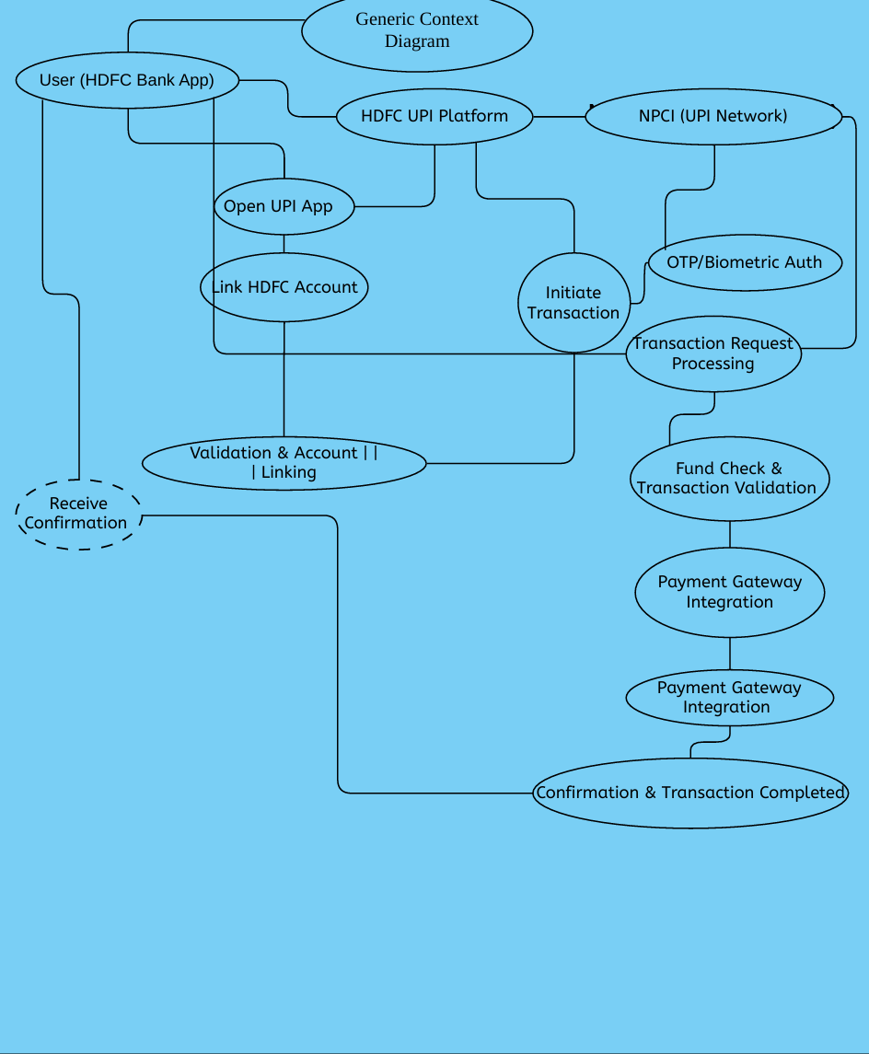

# **4.1 User Registration and Authentication**

* **Account linkage**: Users should be able to link their HDFC Bank accounts to the UPI system.
* **Authentication:** Describe the authentication process (e.g., PIN-based, biometric authentication).

# **4.2 Payment Processing**

* UPI Transaction Types: Explain various types of transactions (e.g., peer-to-peer, merchant payments, bill payments)
* Real-time payments: Transactions should be processed instantly.

# **4.3 Security Features**

* Two-factor authentication: If applicable, two-factor authentication for additional security during transactions.

# **4.4 User Interface (UI) Design**

[Provide wireframes or a description of the user interface for both mobile platforms]

# **Wireframe Design**

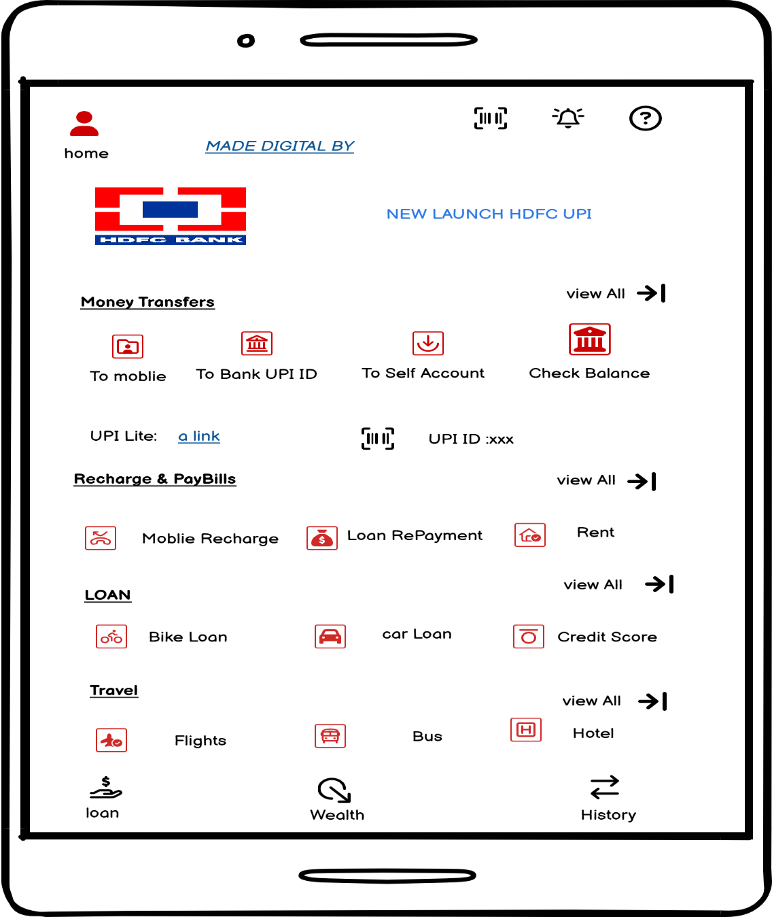

# **4.5 Transaction History**

[Users should be able to view transaction history, including past payments and pending requests.]

# **4.6 Notifications**

Notifications for successful transactions, failed payments, and system updates.

# **4.7 Account Management**

Users should have the ability to manage their linked accounts, update their personal details, and reset passwords.

# **5 Functional Requirements Group 2 – Requirements**

**5.1 UPI-based Transactions**

Users should be able to send money to other UPI-enabled accounts, whether they are HDFC Bank account holders or from other banks.

**Key Functionality**

* Transfer money by entering recipient UPI ID or scanning a QR code.
* Option for splitting bills or sending a specific amount to multiple recipients.

# **5.2 Bill Payments**

Users can pay various utility bills (electricity, water, mobile recharge) through the platform.

* Option to save biller information for quicker payments in the future.
* Users can view bills, schedule payments, and set reminders for due bills.

**Key Functionality**

* Immediate processing of the recharge or top-up request.
* Option to enter mobile number or select predefined plans for quick recharge.

# **5.3 Transaction History and Management**

[Users should be able to view a detailed summary of all their transactions.]

**Key Functionality**

* Option to mark and track recurring transactions
* Transaction details such as date, time, recipient, amount, status (successful/failed).

# **5.4 Security and Authentication**

Users should authenticate themselves using two-factor authentication for added security during transactions.

**Key Functionality**

* Biometric authentication (fingerprint/face recognition) for login and transaction approval, where supported.
* OTP (One-Time Password) sent to the registered mobile number for all financial actions.

# **5.5 Secure Data Encryption**

All user data, including personal details and financial transactions, must be encrypted using strong encryption standards**.**

**Key Functionality**

* Compliance with data protection regulations like GDPR, ensuring the privacy and safety of user data.
* Secure storage of sensitive data like UPI ID, account numbers, and transaction details.

# **5.6 User Interface (UI) and User Experience (UX)**

The system should provide an intuitive, easy-to-navigate interface for mobile platform, making it simple for users to perform transactions.

**Key Functionality**

* Clear, minimalistic design with easily accessible menu options.
* Access to frequently used features such as transaction history, bill payments, and account settings with one tap.

# **5.7 Multi-Language Support**

The platform should support multiple regional languages to cater to a diverse user base.

**Key Functionality**

* Support for Hindi, Tamil, Telugu, Kannada, and other regional languages.

# **5.8 Third-Party Payment Gateway Integration**

Integration with third-party payment gateways for supporting bill payments, merchant transactions, and recharges.

**Key Functionality**

* Ability to handle payments to multiple external systems (e.g., mobile carriers, utilities, online merchants).

# **Requirement Gathering**

|  |  |  |  |
| --- | --- | --- | --- |
| **Feature** | **Description** | **User Benefit** | **System Requirements** |
| **User Registration & Onboarding** | Simple and intuitive process to create a new account, either with an HDFC Bank account or through UPI ID. | Easy registration with minimal steps. | User registration API, integration with HDFC Bank accounts, OTP/KYC verification. |
| **Peer-to-Peer (P2P) Transfers** | Send money to friends, family, or any other UPI user instantly using their UPI ID or QR code. | Instant and hassle-free money transfers. | UPI integration with HDFC Bank and external UPI systems, real-time transaction processing. |
| **Bill Payments** | Pay utility bills such as electricity, water, gas, and mobile bills directly through the app. | Quick and centralized bill payments. | Integration with billers, utility companies, payment gateways. |

# **6 Important Equipment Gathering**

The process of identifying and collecting the necessary tools, resources, software, hardware, and other assets required to successfully implement or launch a project, such as the HDFC UPI New Launch**.**

# **6.1 Hardware Equipment**

* Dedicated servers or cloud services like AWS, Google Cloud, or Azure for hosting UPI systems, user data, and transaction management**.**

# **6.2 POS Terminals and QR Code Generators**

* Devices and systems for merchants to accept UPI payments through QR codes.

# **6.3 Mobile Devices (for Testing)**

* Android and iOS devices for testing the UPI app across different screen sizes, OS versions, and device capabilities.

# **6.4 Network Infrastructure**

* High-speed, reliable internet connections to handle large-scale transactions in real-time.

# **7 Software and Tools**

# **7.1 UPI Integration Software**

* **NPCI (National Payments Corporation of India)** or other third-party vendors to integrate UPI with the HDFC Bank systems.

# **7.2 Banking and Transaction Software**

# Software for managing banking transactions, balance management, user data security, and real-time transaction processing.

# **7.3App Development Tools**

* Mobile app development software (e.g., Android Studio for Android, Xcode for iOS) for creating and testing the HDFC UPI mobile application.

# **8 Testing Equipment and Tools**

# **8.1 Device Testing Lab**

* A set of mobile devices (both Android and iOS) for manual testing to ensure cross-device compatibility and a smooth user experience.

# **9 Communication and Collaboration Tools**

# **9.1Project Management Tools**

* Tools like Jira, Trello, or Asana to manage development sprints, track tasks, and collaborate with teams during the project lifecycle.

# **9.2Collaboration Platforms**

* Platforms like Slack, Microsoft Teams, or Google Meet to facilitate team communication, especially for remote teams.

# **10 Backup and Disaster Recovery Equipment**

# **10.1 Data Backup Solutions**

* Backup systems to store sensitive user data, transaction history, and app-related data to ensure business continuity in case of a disaster.

# **Future Features for HDFC UPI Launch**

# **(Requirement Gathering)**

**11** **Voice-Based UPI Payments**

Enabling users to make UPI payments using voice commands through integration with virtual assistants like Google Assistant, Siri, or Alexa.

* Secure voice authentication: Users can authorize transactions via voice recognition for enhanced convenience.

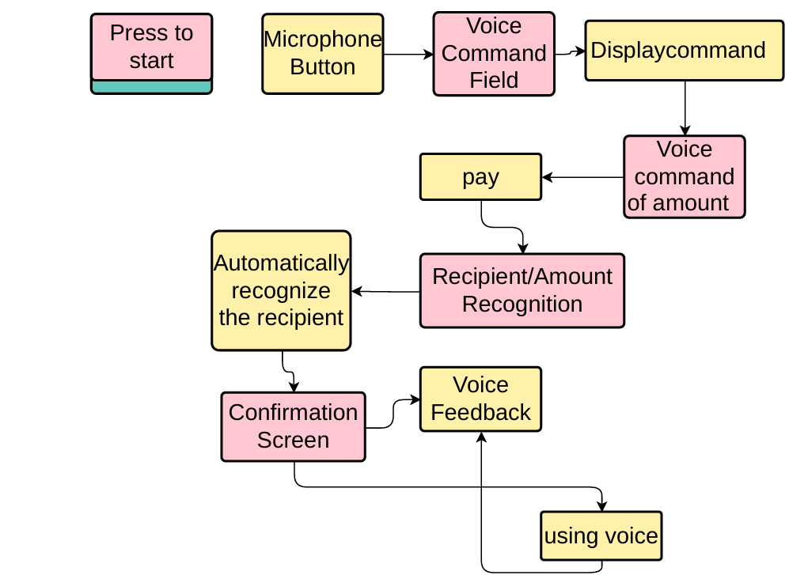

# **11.1 Cross-Border UPI Payments**

Expanding UPI's use for international remittance and cross-border payments.

* Users can send UPI payments to international bank accounts or wallets.

# **11.2 QR Code Dynamic Payment System**

Introducing dynamic QR codes that change with each transaction to enhance security.

* Dynamic QR codes for merchants: Merchants can generate unique QR codes for every transaction, ensuring secure payments and reducing fraud.
* Refunds via QR: In case of disputes, the merchant can generate a dynamic QR code for processing refunds instantly.

# **11.3 Contactless UPI Payments**

Enabling contactless payments via UPI by linking it with NFC-enabled devices (smartphones, wearables).

* Zero touch, faster transactions: Facilitating faster checkouts in retail and transportation services by eliminating the need to enter a UPI PIN for small amounts.
* Seamless transactions for low-value payments: Transactions under a set limit can be completed without entering PINs for added convenience.

# **11.4 UPI for Bill Payments and Subscriptions**

Enabling UPI to handle recurring bill payments and subscription-based services automatically.

* Automated bill payments: Setting up automatic payment for utilities like electricity, water, broadband, and insurance premiums via UPI.

# **11.5 Enhanced Security Features**

Incorporating advanced security measures to protect user data and transactions.

* Biometric authentication: Enabling biometric (fingerprint, face recognition) login for accessing UPI accounts and authorizing transactions.

# **11.6 UPI in Offline Mode**

Allowing users to make UPI transactions even when there is no internet connection available.

* Offline UPI transactions: Users can complete transactions using SMS or USSD codes when they don’t have access to mobile data or Wi-Fi.
* Pending transactions: Offline transactions will be processed once the network connection is restored.

[**Old Feature Usage Example: Example Data:**

* Old Feature Usage: 60% of total transactions (basic payments, peer-to-peer transfers).
* New Feature Usage: 40% (AI-based recommendations, voice-enabled payments, etc.]

# **11.7 Gamification and Rewards**

Adding **gamification elements** and rewards to make UPI transactions more engaging.

* Cashback offers: Providing rewards or cashback on UPI payments made for certain services, such as bills or shopping.
* Transaction challenges: Encouraging users to complete a certain number of transactions in a given time frame to earn rewards.

[When comparing **old** rewards and **new** rewards, it's important to recognize how the types of rewards offered have changed based on user preferences, market trends, and advancements in technology.]

[An **12 APPENDIX A – GLOSSARY**

effective Glossary section helps ensure that all stakeholders, including developers, business analysts, project managers, and users, can easily understand the technical and business terms]